Wave Maker

Subject: Waves, Circuits, Structures  Related Subjects: Electronics, Mechanical, Physics | Grade Level(s): 2,3,4,5,6,7,8  Length of Lesson: | Type: Inquiry / Design / Project  Keywords:Series-parallel circuit, wavelength, node, crest, trough

Lesson Overview

The most important areas of the world around are connected in some way to waves. Sound, light, water, radiation, electricity all are dependent upon waves. Understanding the basic nature of waves is essential to understanding science.

Lesson Focus
Students will create a wave maker machine to better see the key elements of waves.

Lesson Objective(s) | - Students will create a machine that can demonstrate various wave shapes  - Students will use the wave machine to demonstrate various wave shapes

Lesson Timing

5 minutes | Introduce the Lesson
30 minutes | ...

Materials | –1/2” PVC Tees  –1/2” PVC elbows  –Saw  –1.5v motors  –String  –Insulated wire  –Battery holder  –Batteries  –Wire cutter/strippers  –1/2” PVC pipe  –3/8” dowels  –Pipe fastener  –plywood  –zip ties  –Toggle switch  –Hot glue gun  –Glue sticks  –Electrical Tape
Instructor Prep | - Step 1
Related Resources | - List related lessons/ppts etc available from USC or outside, trusted orgs

Lesson Plan

Introduction
Waves can be characterized them by their wavelength.
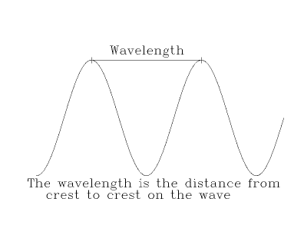
To understand wavelength, let's use an analogy to the waves on the ocean. Think about what happens to a small boat bobbing on the ocean. If the distance between the wave crests is large ( i.e. the wavelength is long), then the boat bobs up and down less often ( the frequency is low); if the distance is small ( i.e. the wavelength is short), then the boat bobs up and down more often ( the frequency is high).

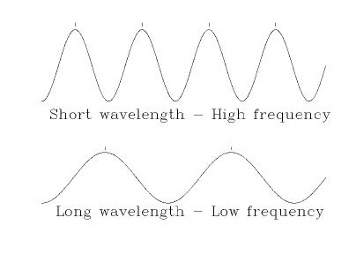
Differing frequencies and wavelengths are what make colors unique, sound different and radiation intense. Most of the time we experience the effect of waves and don’t observe them.
The wave maker will give the students an opportunity to see different waves. Students will create series-parallel circuits.

A series circuit is formed when an electrical source (battery) is connected to an object (motor, light…), which is connected to a switch, which is connected back to the battery.
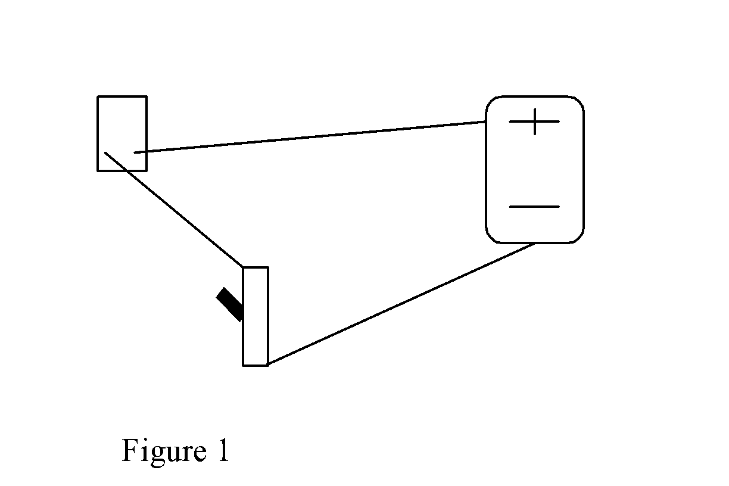

When the switch is off, the circuit is open and electricity can’t flow. When the switch is on, the circuit is closed and electricity can flow.

In this instance, a series-parallel circuit occurs when two objects are connected to the same two points (a parallel connection) in the series circuit.
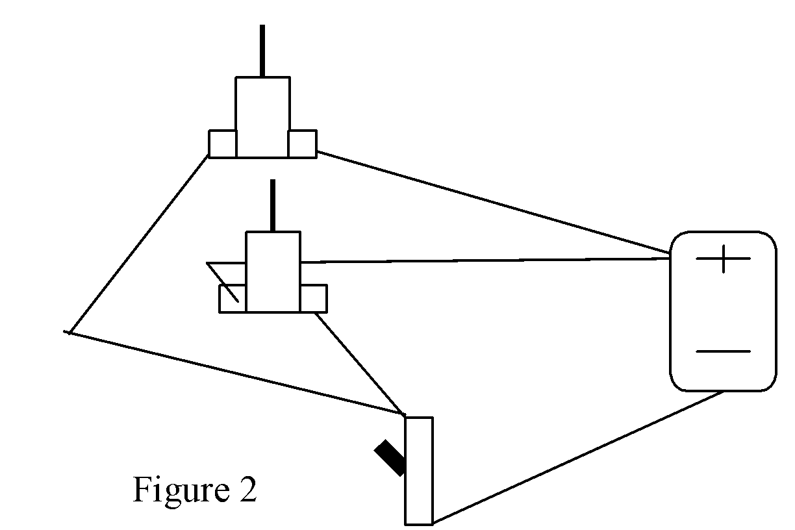

The two motors of the wave maker should be connected in a same manner as shown in figure 2. In addition, both motors must turn in the same direction when they are set facing each other (figure 3)

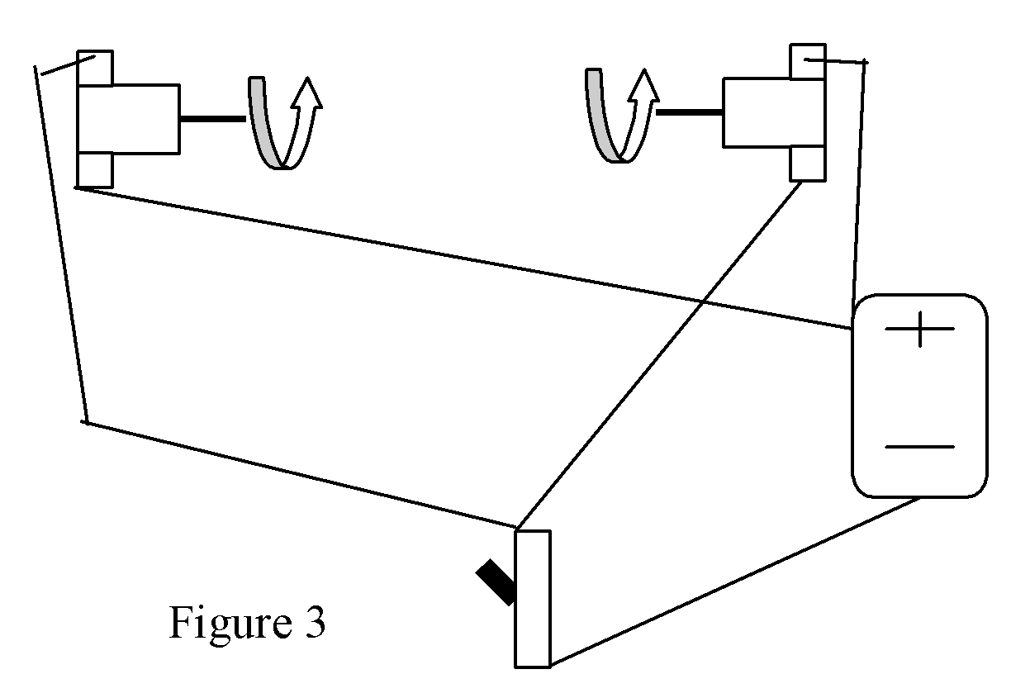

The motors are then mounted facing each other, connected with a string and viola, the wave maker is born (figure 4)

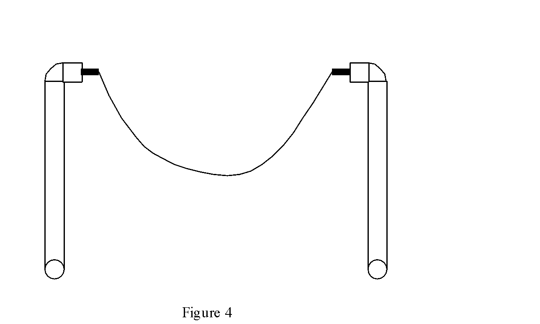

Procedure
Components and Parts

- –Cut 2-10” pieces of PVC pipe
- –Cut 4-18” pieces of insulated wire
- –Strip ½” from both ends of each wire
- –Strip the wires of a battery holder.
- –Cut 2 wood rectangles 3” x 2”
- –Cut 1 wood rectangle 11” x 1”.
- –Cut 2-1” pieces of dowel
- –Drill in the center of either end of one piece about ½”
- –On the other end drill completely through the side of the dowel
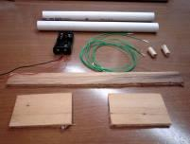
Construction

- –Glue short wood rectangles to opposite ends of long rectangle
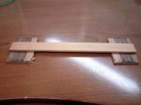
- –Connect one wire to one lead of 1st motor.
- – Connect second wire to other lead 1st of motor.
- – Connect third wire to one lead of 2nd motor.
- – Connect fourth wire to other lead 2nd of motor.
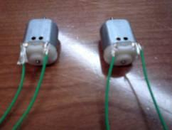
- – Tape wires in place
- –String free wires from 1st motor through PVC elbow
- –String free wires from 1st motor down length of one of the PVC pipes until both wires protrude from other end.
- –Attach PVC elbow to PVC pipe
- –String wires through mouth of PVC Tee and pull one wire out of each side.
- –Insert PVC pipe into PVC Tee securely.
- – Attach PVC elbow to other 12” piece of PVC pipe
- –Follow same procedure for remaining motor and PVC pipe.
- –These are your motor mounts
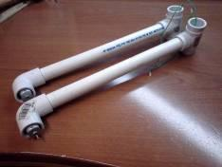
- –Attach 1st motor mount with zip ties while still allowing motor mount to move approximately 2” in either direction from the perpendicular.
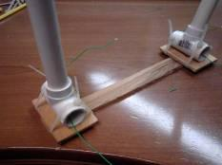
–Attach 2nd motor mount in the same way.
–Cut 12” string
–Insert the string through side holes on both pieces of dowel.
–Tie knots in ends of string on both sides to keep it from slipping out (you may wish to put a little glue on dowel to help hold).
–Mount dowel on stem of motor on one of the motor mounts (you may nee to put a little glue in dowel hold to help secure it to motor stem)
– Repeat for 2nd piece.
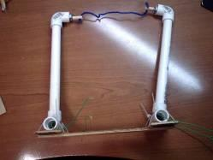
–Test both motors with batteries to determine which wire should be connected to the positive (red) wire of the battery holder to make both motors turn the same direction.
–Twist the those two wires from each motor together.
–Insert twisted pair to the center post of the switch and tape
–Connect red wire from battery holder to either end post of switch and tape (if use double pole switch, make sure all connections are on same side)
–Twist remaining two wires together with black wire of battery holder and tape
–Glue switch and battery holder to wood.
–Tape motors in place
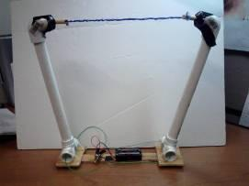

–Insert batteries, turn on switch
–Adjust distance between motor mounts and watch the different waves.

Troubleshooting

Make sure motors turn same direction

Wrap-up
- Students can see how many crests they can form by moving mounts.

Lesson Background for Teachers
Safety Procedures
- Students should exercise caution when using saws
- Students should exercise caution when using Soldering Iron
- Students should use caution with saw
- Students should use caution with glue gun

